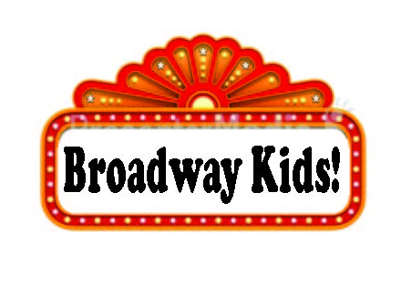

Ethel Boyes Elementary
Registration Form 2019

Name of Student __________________________________________ Age ____________
Address __________________________________________________ Phone _________________
Parent’s (Guardian) name ____________________________________ Email __________________
Add additional family member:
Name ____________________________________________ Age ____
Name ____________________________________________ Age ____
I agree to attend class and rehearsals regularly and on time.

Signed: _____________________________________________________ Date: _________________
******************************************************************************************
10 Program Classes, one dress rehearsal, and three performances –
running from March 4 – May 11
Tuition: $100 per student

Payment Options: Check, Cash, Venmo or *PayPal is accepted. Check or Cash may be turned in at the front office. Our Venmo account is @bffperformingarts. If writing a check, please make it out to: Best Foot Forward Performing Arts. *Note: Paypal payments will have a 4% convenience fee attached.
Tuition: ______________ paid by: Check # Cash Venmo
***We encourage your child to bring a snack to eat prior to class

